**Lesson 8 Demo 4**

**Expose a Deployment as a Service**



**Steps to be followed:**

1. Connecting Azure Cloud Shell to the Kubernetes cluster
2. Exposing a deployment as a service

**Step 1: Connecting Azure Cloud Shell to the Kubernetes cluster**

| **Note:** Follow **Step 3.6** to **Step 3.8** of **Lesson 8 Demo 3** to connect SL-Cluster with Cloud Shell |
| --- |

**Step 2: Exposing a deployment as a service**

1. Navigate to the **BASH** screen and run the following command to expose **second-deploymen**t as a service:

***kubectl expose deployment/second-deployment \***

***--type=LoadBalancer --name=nginx-service -n first-namespace***

1. Check the newly exposed service by executing the below command:

***kubectl get svc -n first-namespace***

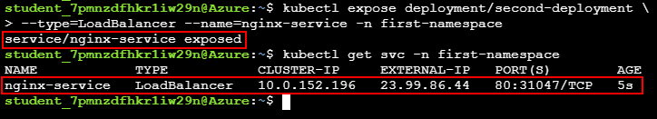

| **Note:** Notice that the service **Type** is set as **LoadBalancer** so that it can be accessed through an **External IP** |
| --- |

1. Now navigate to **Services and ingresses** section in the **SL-Cluster** and click on the **Refresh** button to list the newly created **nginx-service**

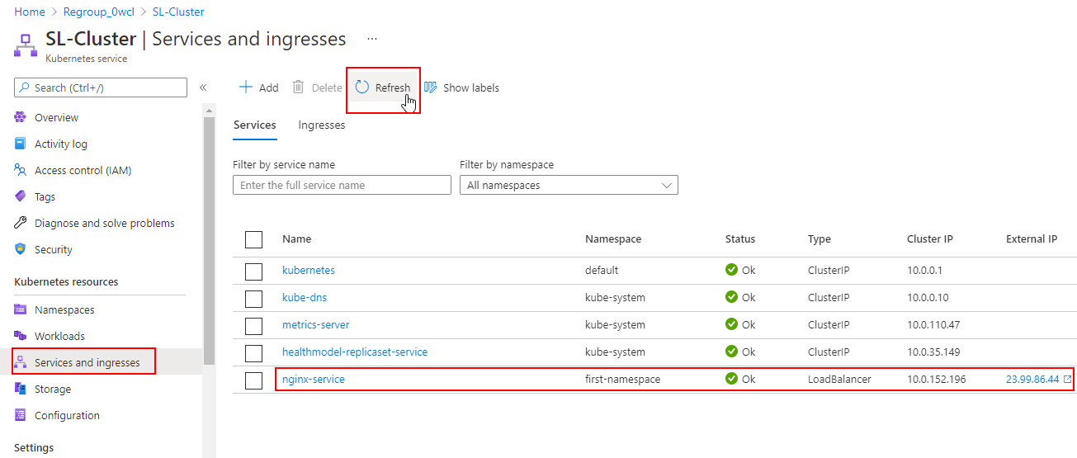

1. Click on the **nginx-service** to go to service **Overview** and click on the **External IP** of the service to access the nginx application

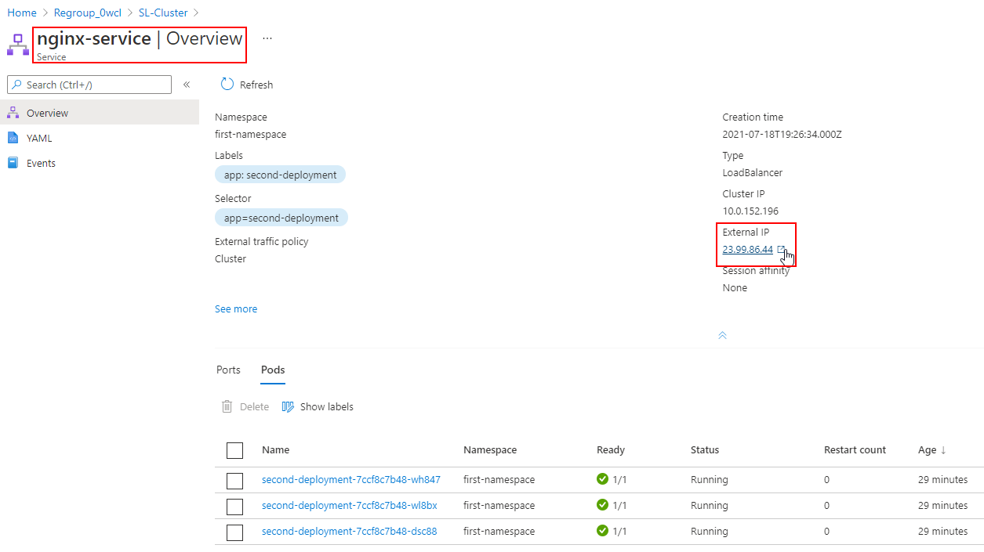

1. Clicking on the External IP will navigate you to the nginx application

